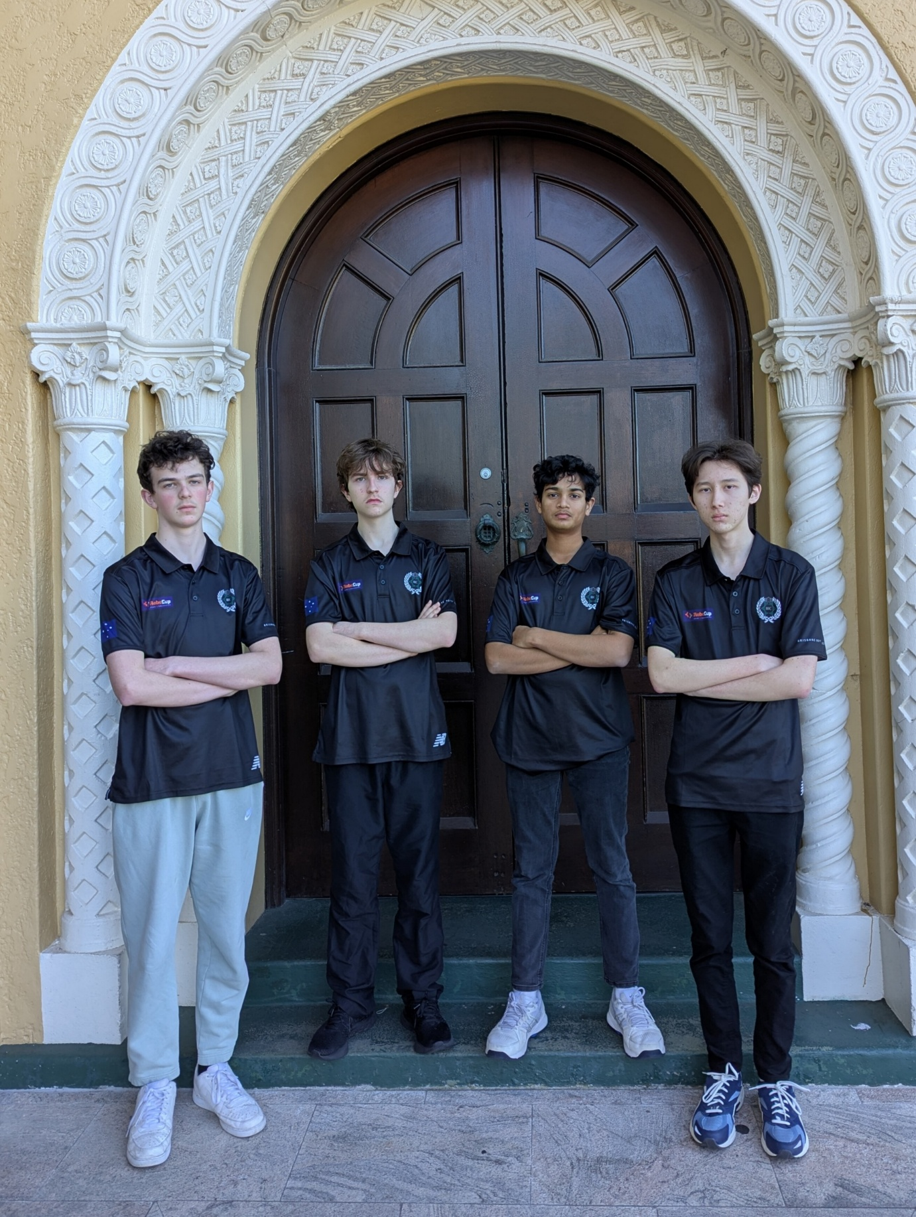

Team Hyperion

2026 RCJ Incheon Interview
1st Speaker – Luke Atherton – Structural
[PICTURE OF ROBOT HERE], [ADD ANY OTHER IMAGES LUKE WOULD LIKE]
2nd Speaker – Matthew Adams – Electrical
[PICTURE OF PCB’S??], [ADD ANY OTHER IMAGES MATTHEW WOULD LIKE]
3rd Speaker – Thomas McCabe – Software – [TOPIC]
[ADD ANY OTHER IMAGES TOM WOULD LIKE]
- Can we possibly have some code extracts in here?? Would be cool
4th Speaker – Sam Garg – Software – Camera Localisation
[ADD ANYTHING SAM WOULD LIKE]

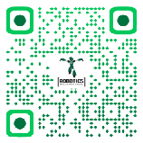
OUR WEBSITE

(Link: team-hyperion.netlify.app)
Check out our website – it has all of our socials, work, and anything that surrounds Team Hyperion on it! If you have any questions, feel free to ask us or simply send us an email.

